Transcriptomic Profiling of Dwarf Tomato (Solanum lycopersicum cv. Red Robin) in Spaceflight: Evaluating the Main Effects of Microgravity Under Red and Blue Light Covariates

Abstract
Background: Cultivating nutrient-dense crops in microgravity is a critical requirement for long-duration human space exploration. The VEG-05 experiment investigated the growth and physiological responses of the dwarf tomato (Solanum lycopersicum cv. Red Robin) aboard the International Space Station (ISS) under varying light spectra. While the phenotypic effects of spaceflight and light quality on crop yield have been documented, the underlying molecular adaptations remain incompletely understood.
Methods: Here, we performed a comprehensive RNA-sequencing (RNA-seq) analysis using data obtained from the NASA Open Science Data Repository (OSD-767). We evaluated differential gene expression in leaf (n=21) and adventitious root (n=15) tissues between ISS spaceflight samples and ground controls. Red and blue light treatments were modeled as covariates to isolate the main effects of the spaceflight environment. Data processing followed an adapted NASA GeneLab RNAseq Consensus Pipeline (GL-DPPD-7101-G), utilizing the Solanum lycopersicum SL3.0 reference genome.
Results:
(To be added - Leaf analysis identified 2,132 significant differentially expressed genes, root analysis is currently pending)
Conclusions: (To be added)

1. Introduction
Long-duration space missions necessitate the development of bioregenerative life support systems capable of providing continuous, fresh, and nutrient-dense food for astronauts. The dwarf tomato (Solanum lycopersicum cv. Red Robin) has emerged as a prime candidate for space agriculture due to its compact size, continuous fruiting habit, and high nutritional value. Understanding how this crop adapts to the unique stressors of the spaceflight environment—specifically microgravity and elevated radiation—is essential for optimizing cultivation strategies in off-Earth habitats.
Plant growth and development are highly plastic and profoundly influenced by environmental cues. In controlled agricultural environments, including the Vegetable Production System (Veggie) aboard the International Space Station (ISS), light quality is a primary driver of plant physiology. Specific wavelengths, particularly red and blue light, dictate photosynthetic efficiency, phototropism, and stress responses. However, it remains unclear how the foundational transcriptomic responses to microgravity interact with or operate independently of these light-quality cues.
The VEG-05 experiment (NASA Open Science Data Repository dataset OSD-767) was designed to evaluate the impacts of different light qualities (Red vs. Blue) on tomato growth, nutrient composition, and microbial safety in space. In this study, we leverage the transcriptomic data generated from VEG-05 to isolate the fundamental genetic adaptations of S. lycopersicum to spaceflight. Rather than testing for a flight-by-light interaction, we modeled light condition as a covariate. This approach allows us to determine the robust, primary effects of spaceflight on both foliar and root transcriptomes, averaged across varied light spectra, thereby identifying the core molecular footprint of spaceflight adaptation in a vital crop species.

2. Materials and Methods

2.1 Experimental Design and Data Acquisition
Raw RNA-sequencing data (FASTQ format) for the VEG-05 experiment was accessed and downloaded from the NASA Open Science Data Repository (OSDR), dataset OSD-767 (GeneLab ID: GLDS-709). The dataset comprises transcriptomic profiles of Solanum lycopersicum cultivar "Red Robin" subjected to two distinct environments: Spaceflight (aboard the ISS) and Ground Control (simulated ISS environmental conditions). Within these environments, plants were grown under specific light treatments (Red light and Blue light).
The experimental design consisted of 21 leaf samples and 15 adventitious root samples. Leaf samples were distributed as follows: Spaceflight/Red (n=5), Spaceflight/Blue (n=4), Ground/Red (n=6), and Ground/Blue (n=6). Root samples exhibited an imbalanced distribution due to tissue availability: Spaceflight/Red (n=5), Spaceflight/Blue (n=4), Ground/Red (n=3), and Ground/Blue (n=3).

2.2 Pre-processing and Quality Control
Data processing was carried out on a provisioned high-performance computing environment (16 CPU, 64 GB RAM) and closely adhered to the NASA GeneLab RNAseq Consensus Pipeline specification (GL-DPPD-7101-G / NF_RCP 2.0.1). Due to the organism's absence in the standard GeneLab annotation tables, reference retrieval and processing steps were executed manually following the pipeline's algorithmic standards.
Raw paired-end sequencing reads (151 bp, sequenced via NovaSeq X Plus) were evaluated for quality using FastQC (v0.12.1) and aggregated with MultiQC (v1.26). Adapter sequences and low-quality bases were removed using TrimGalore! (v0.6.10), utilizing Cutadapt (v4.2) under the hood with parameters set to --phred33 and paired-end mode. Post-trimming read quality was subsequently verified via a second pass of FastQC.

2.3 Read Alignment and Quantification
Because the Solanum lycopersicum reference is not auto-provisioned by the GeneLab pipeline, the Ensembl Plants SL3.0 genome assembly and corresponding ITAG4.0 gene model annotations (Release 59) were utilized as the reference.
Trimmed reads were aligned to the SL3.0 reference genome using STAR (v2.7.11b) in two-pass mode. To accommodate the 151 bp read lengths, the splice junction database overhang parameter (--sjdbOverhang) was set to 150. Additional alignment parameters followed standard GeneLab guidelines, including strict filters for multi-mapping (--outFilterMultimapNmax 20) and mismatch rates (--outFilterMismatchNoverReadLmax 0.04), outputting coordinate-sorted BAM files alongside transcriptome-aligned BAMs.
Transcriptome BAM alignments were quantified using RSEM (v1.3.1). Expression estimates were calculated utilizing the --estimate-rspd flag. Read strandedness, inner distance, gene body coverage, and read distribution were empirically determined prior to quantification using RSeQC (v5.0.4) to inform RSEM parameters.

2.4 Differential Gene Expression Analysis
Differential gene expression (DGE) analysis was conducted in the R statistical environment (v4.4.2) using the DESeq2 package (v1.50.2). Gene-level counts were imported from RSEM output files using the tximport package (v1.38.2).
Leaf and root tissues were analyzed in completely independent DESeq2 workflows to account for fundamental baseline expression differences between tissues. To identify the primary effect of spaceflight while controlling for variations introduced by the light treatments, "light condition" (Red/Blue) was established as a covariate in the design formula: ~ light + condition.
The primary contrast evaluated was Spaceflight versus Ground control. Prior to statistical testing, genes with consistently low counts were pre-filtered to improve statistical power. To manage the sample imbalance present in the adventitious root dataset, DESeq2's internal dispersion estimations and modeling were relied upon to robustly handle unequal replication.
Log2 fold change (LFC) estimates were shrunken using the VST method to account for expression variance in genes with low counts. Significant differentially expressed genes (DEGs) were defined utilizing a Benjamini-Hochberg adjusted p-value (FDR) threshold of < 0.05 and an absolute log2 fold change of ≥ 1.0. High-level data visualizations, including volcano plots, MA plots, and Principal Component Analyses (PCA), were generated using EnhancedVolcano (v1.28.2) and internal DESeq2 plotting functions.

3. Results
3.1 dispersion and PCA
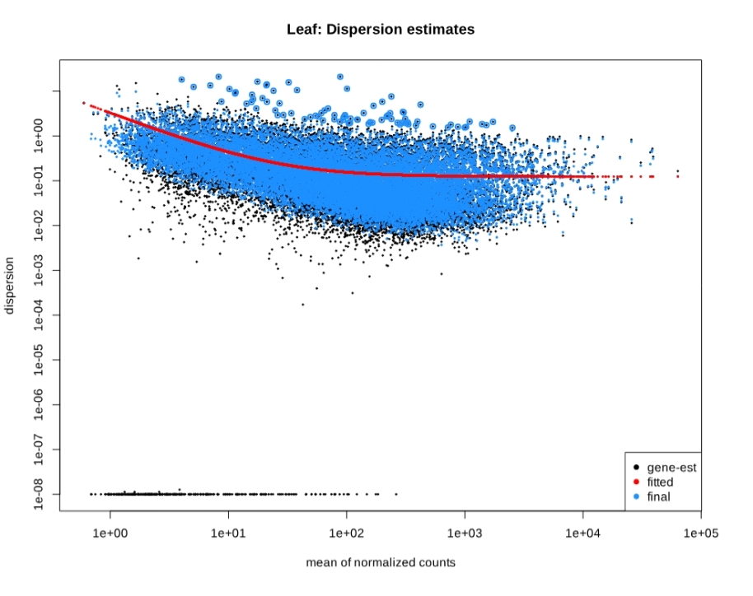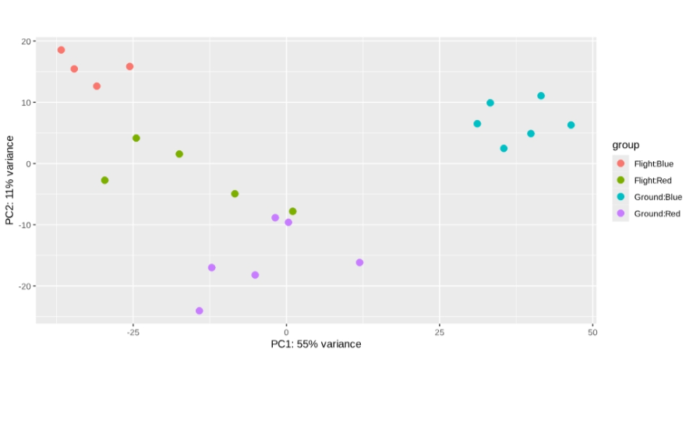
3.1 Leaf sample flight vs ground.

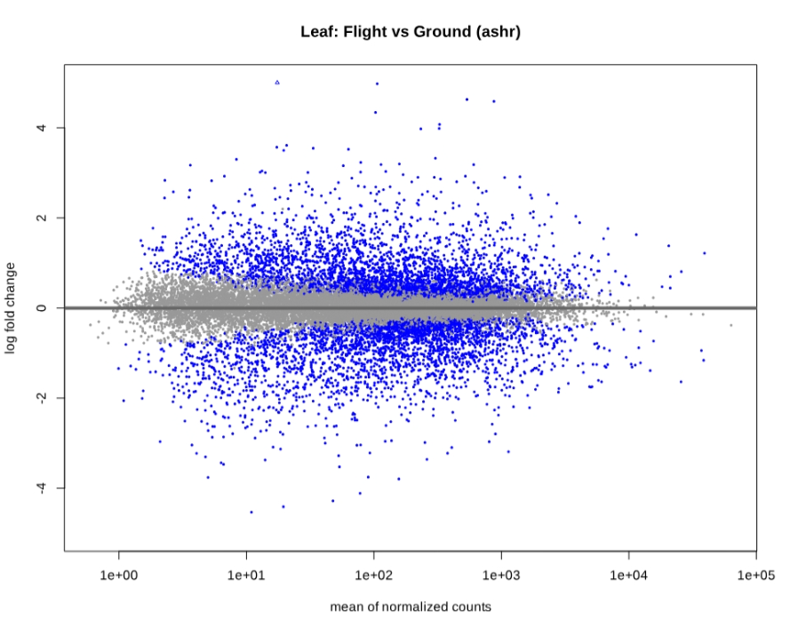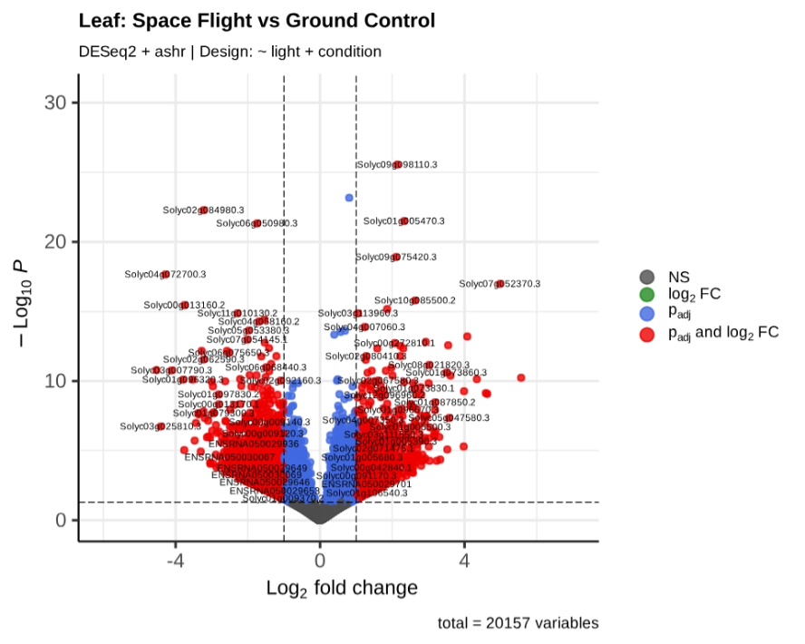

3.2 Root sample flight vs ground.

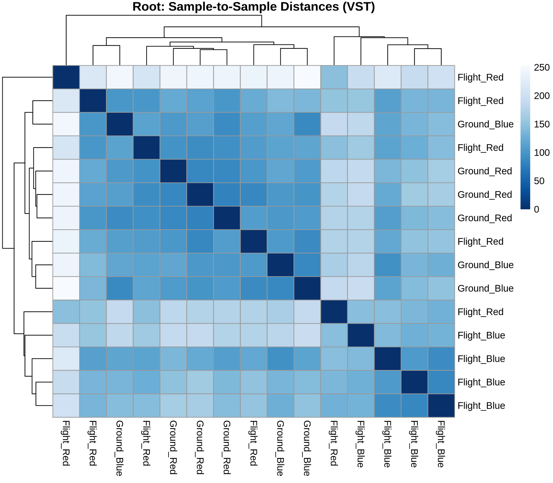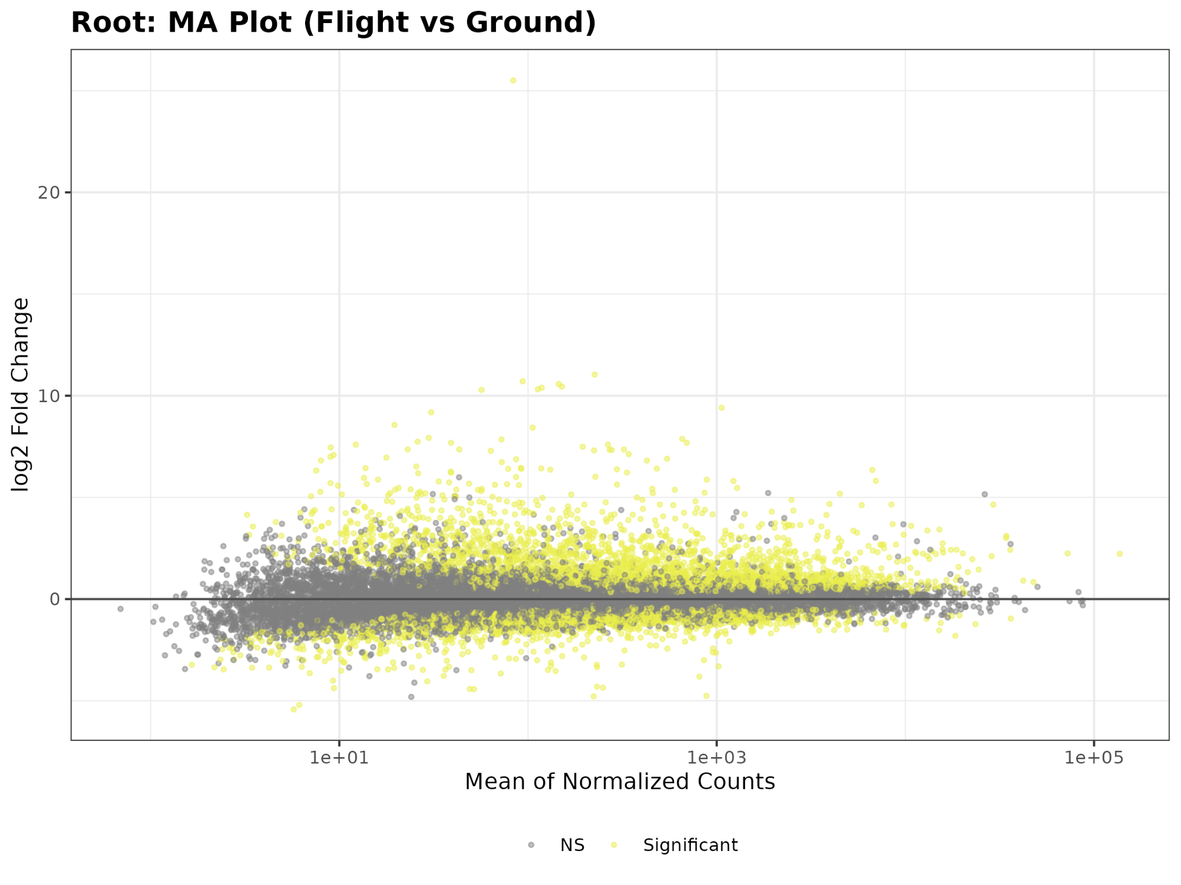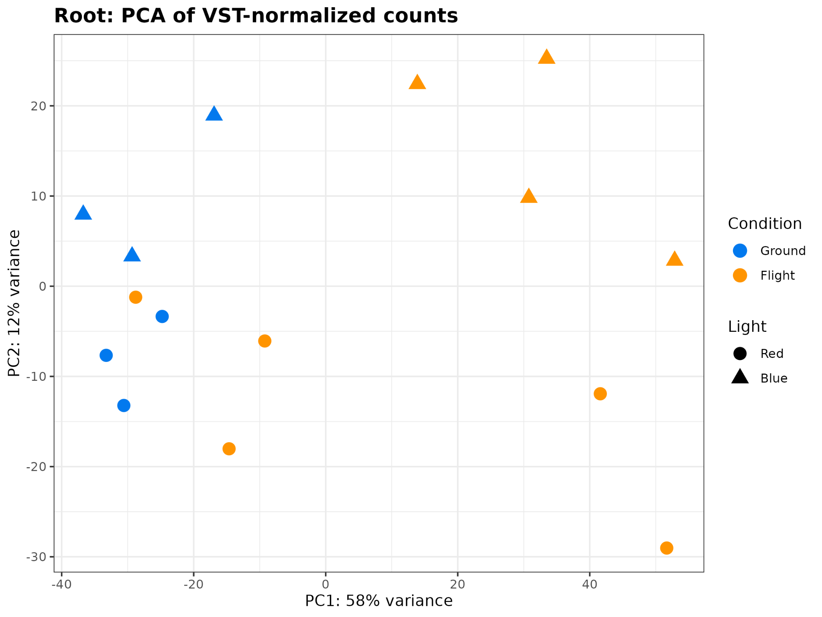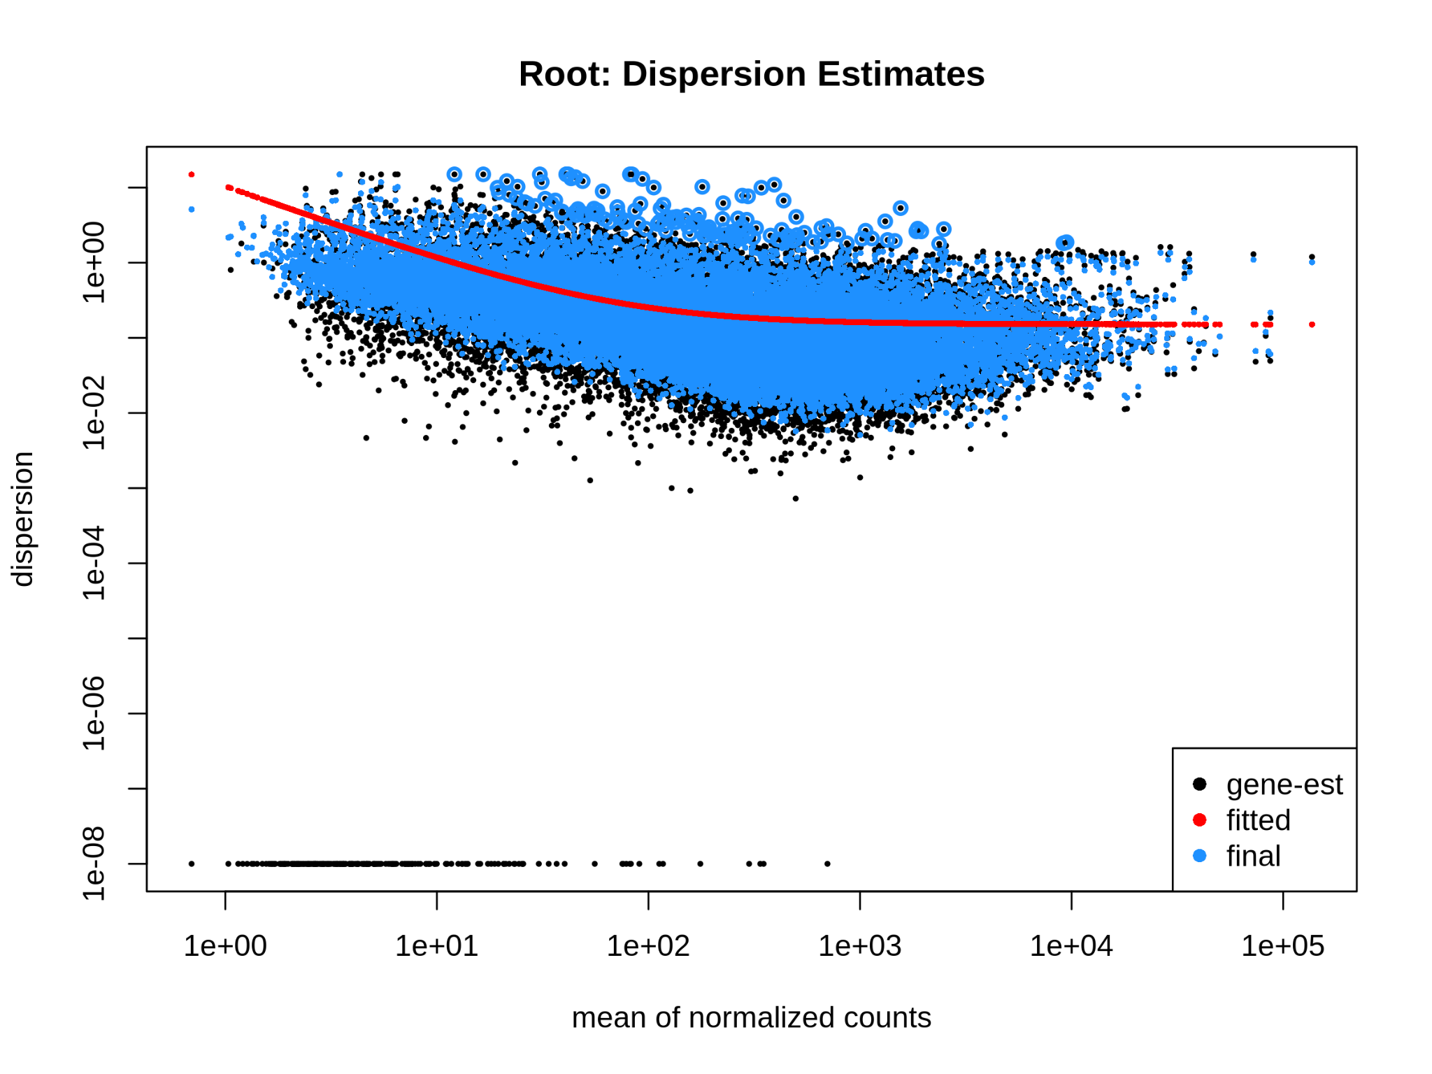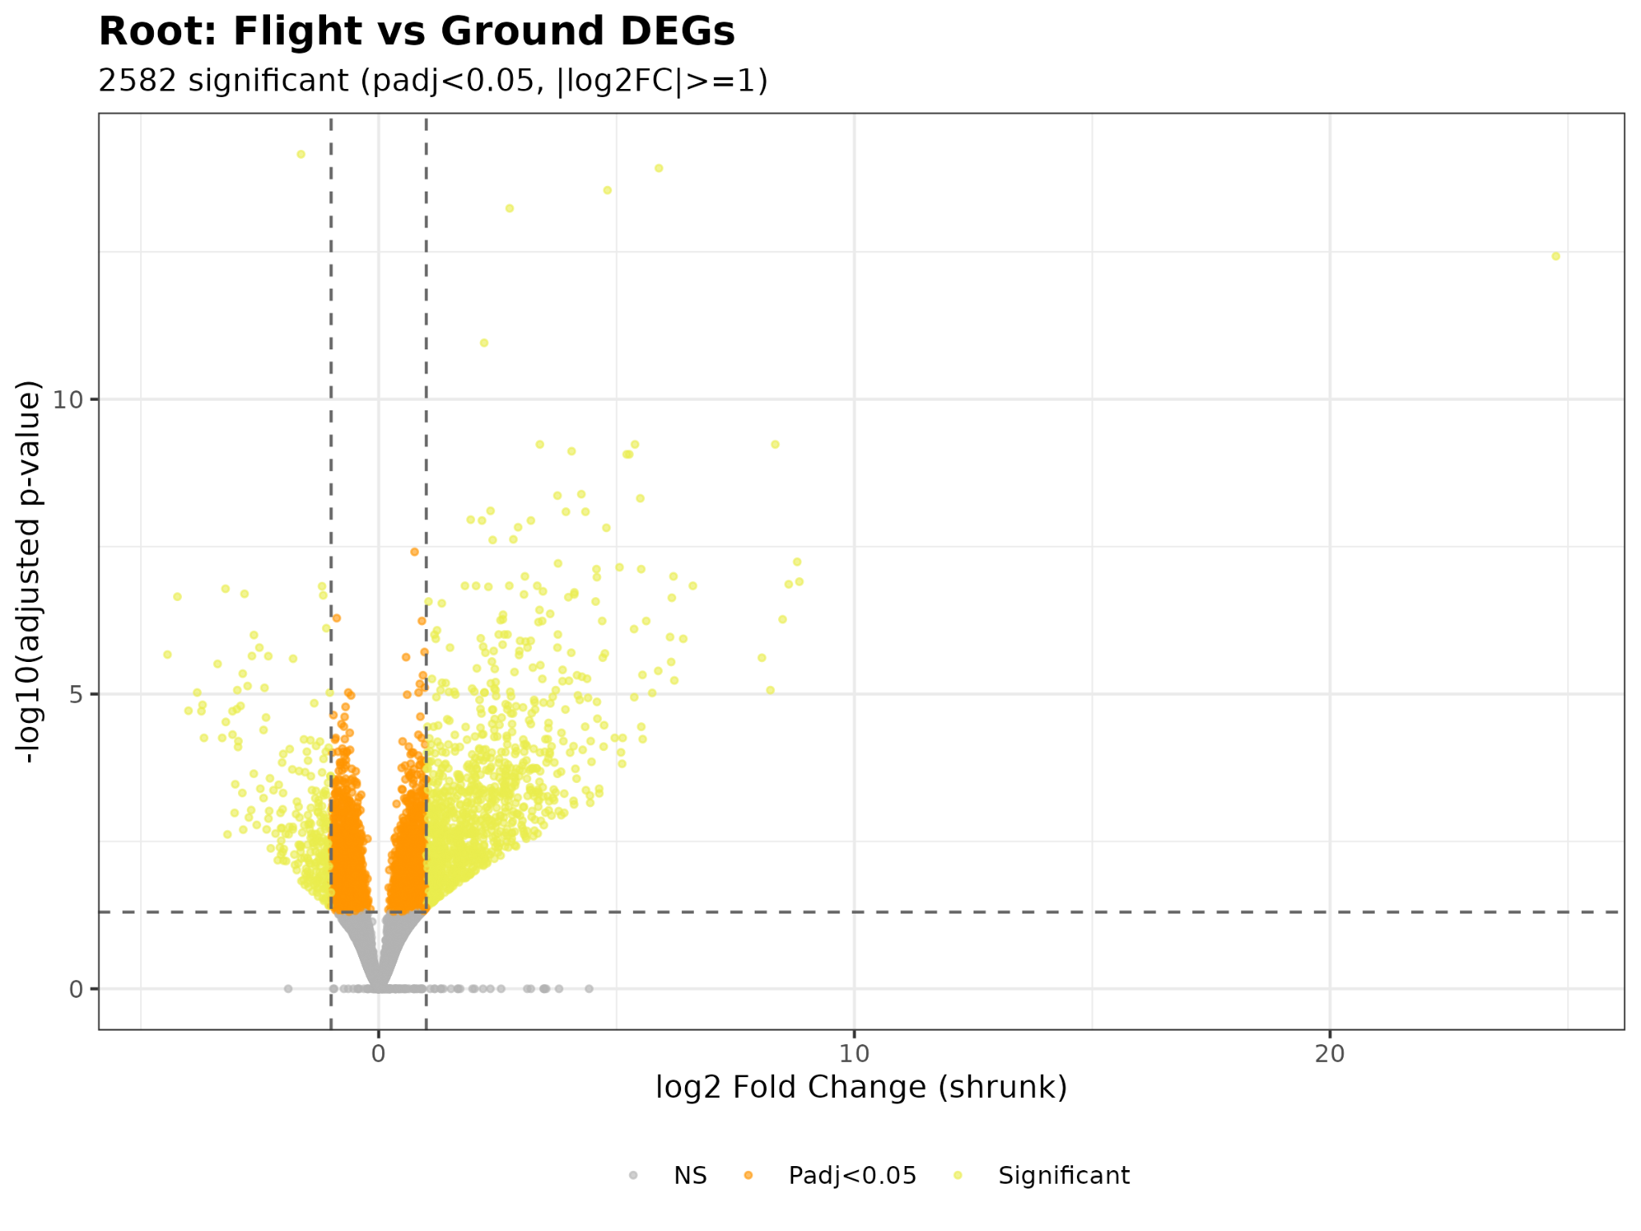

4. Discussion
(To be populated upon completion of the analytical pipeline)

